Suspects’ shoe prints
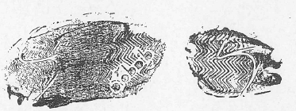
Michael Beards
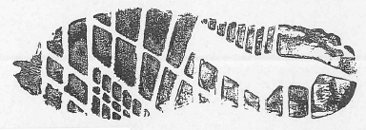
Robert Forte
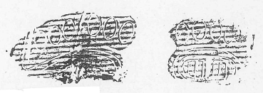
Owen Davies
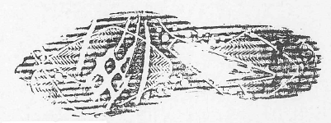
Kamill Jinzarli
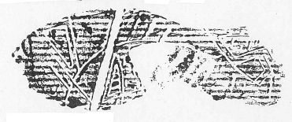
Blair Pasco
Soil footprints were found by the doorway to the gym entry. Photographs of the shoeprint were collected and catalogued by the crime scene examiners. It was estimated that the shoeprint was made by a size 11 sports (jogging) shoe.

